Application deployment into an Instance under VPC

Planning:

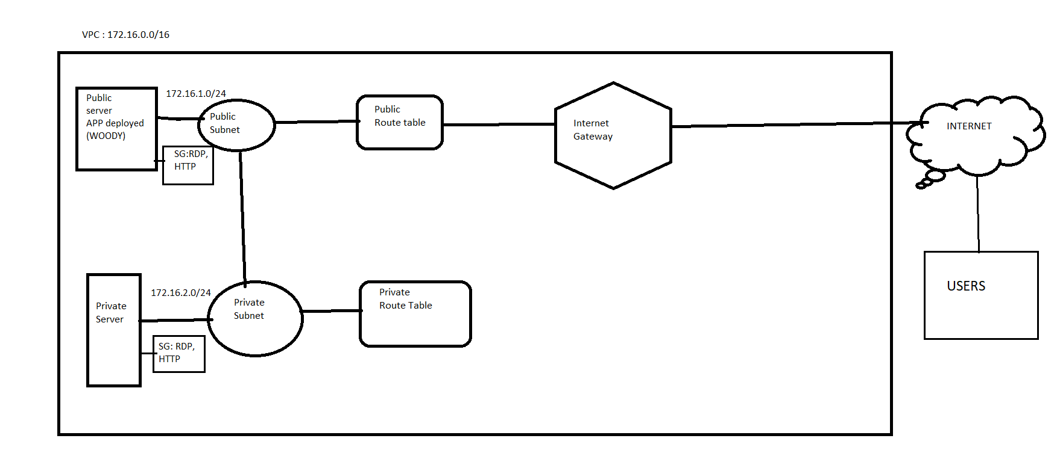

Steps to create one VPC:

VPC: Its is a creation of an isolated network over public cloud where the resources are identified by unique IP.

VPC is region specific where in one region we can create 5VPC. But cannot create same vpc to diff regions.

Step 1:

Creating one vpc with the CIDR range :172.16.0.0/16(65,536 ip) in one region.

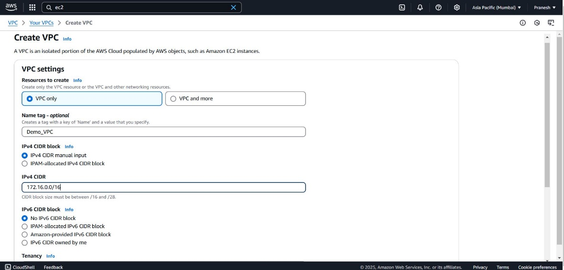

Step 2:

Under the created VPC create Public subnet (with range 172.16.1.0/24) and Private subnet (with range 172.16.2.0/24).

Public subnet: it is to connect to internet gateway where users can access services through internet.

Public:

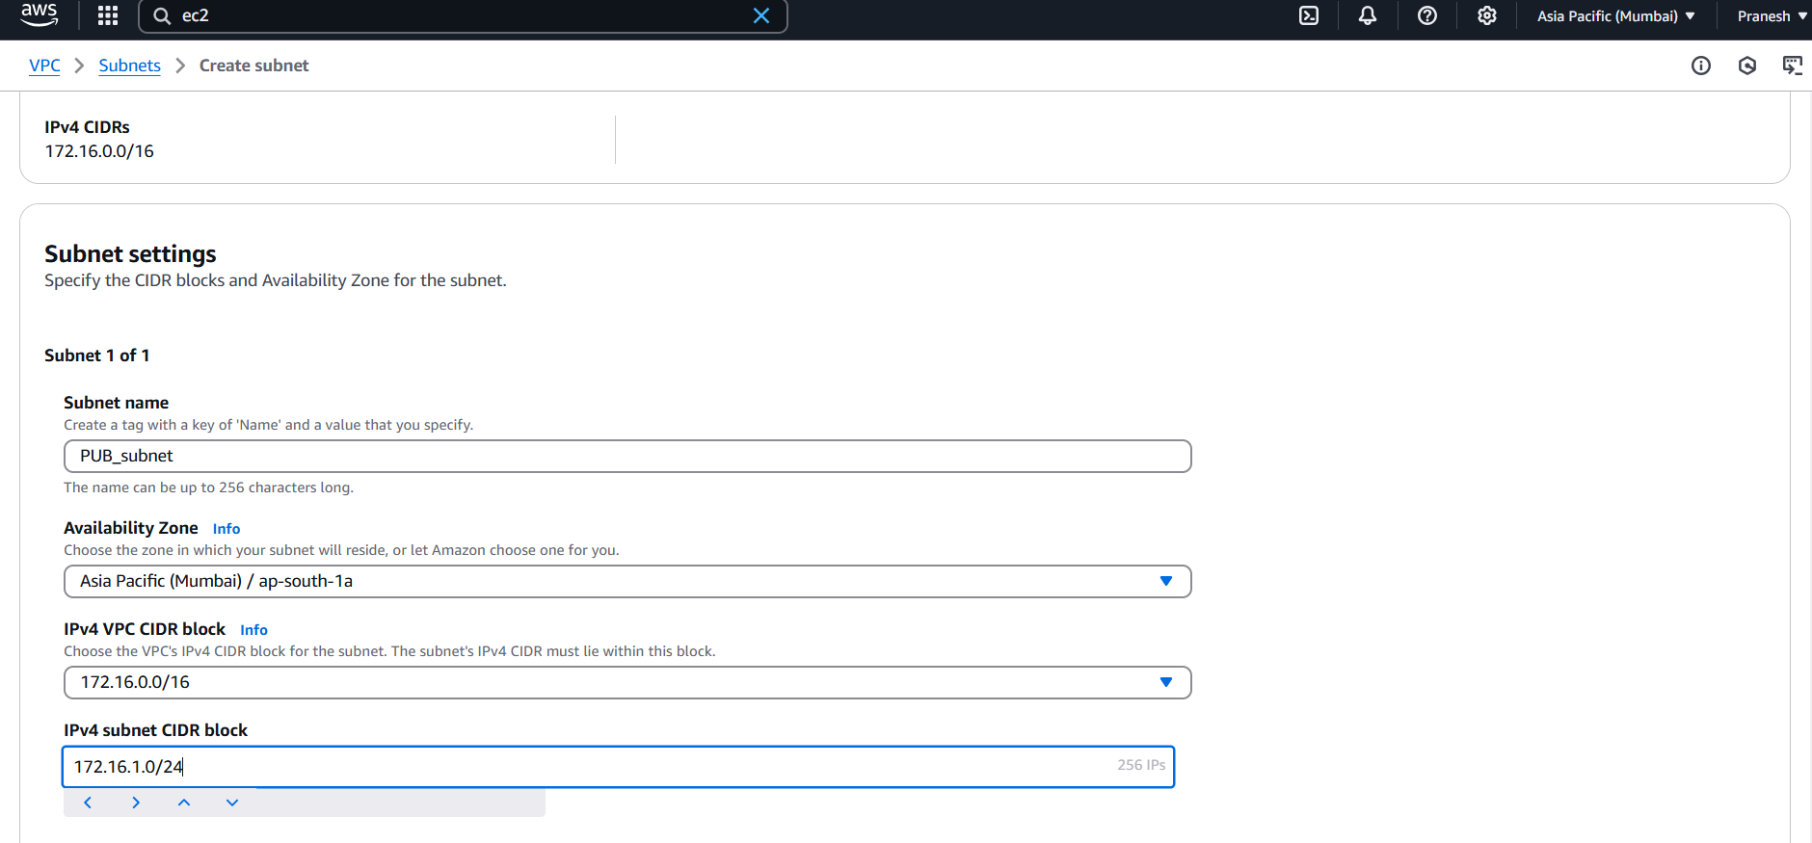

Private:

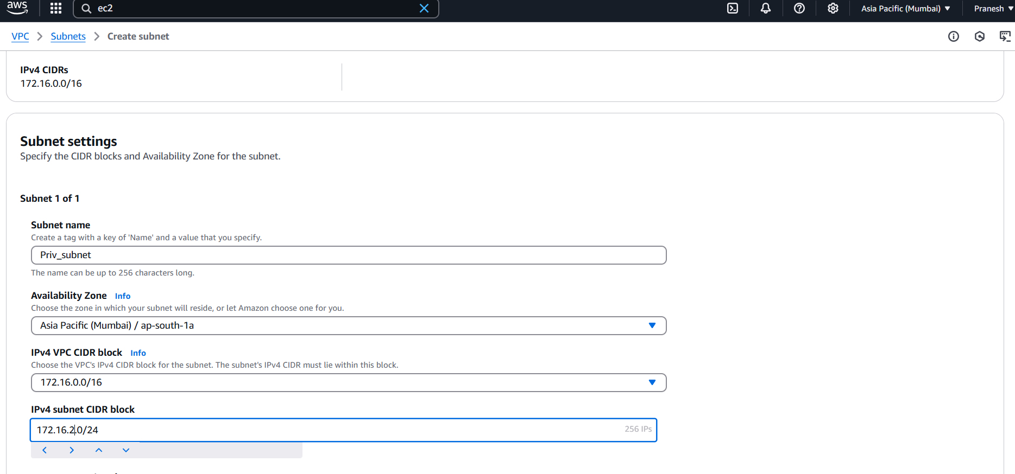

Step 3:

Create Public and Private Route tables:

Route table is to route ip to the paths.

Public RT nd Private RT:

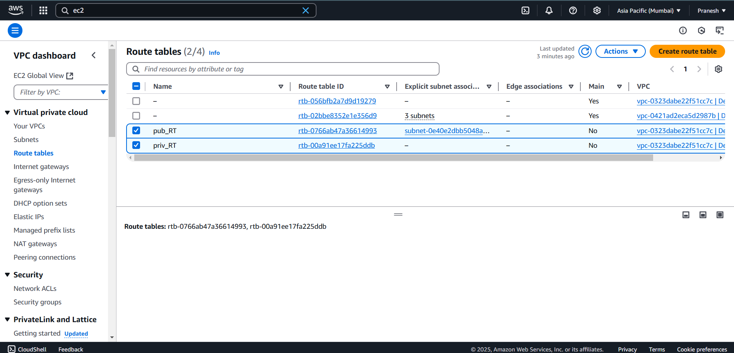

Step 4: Create an internet gateway and attach to VPC

IGW is where the Local network can communicate to the external network(public Internet).

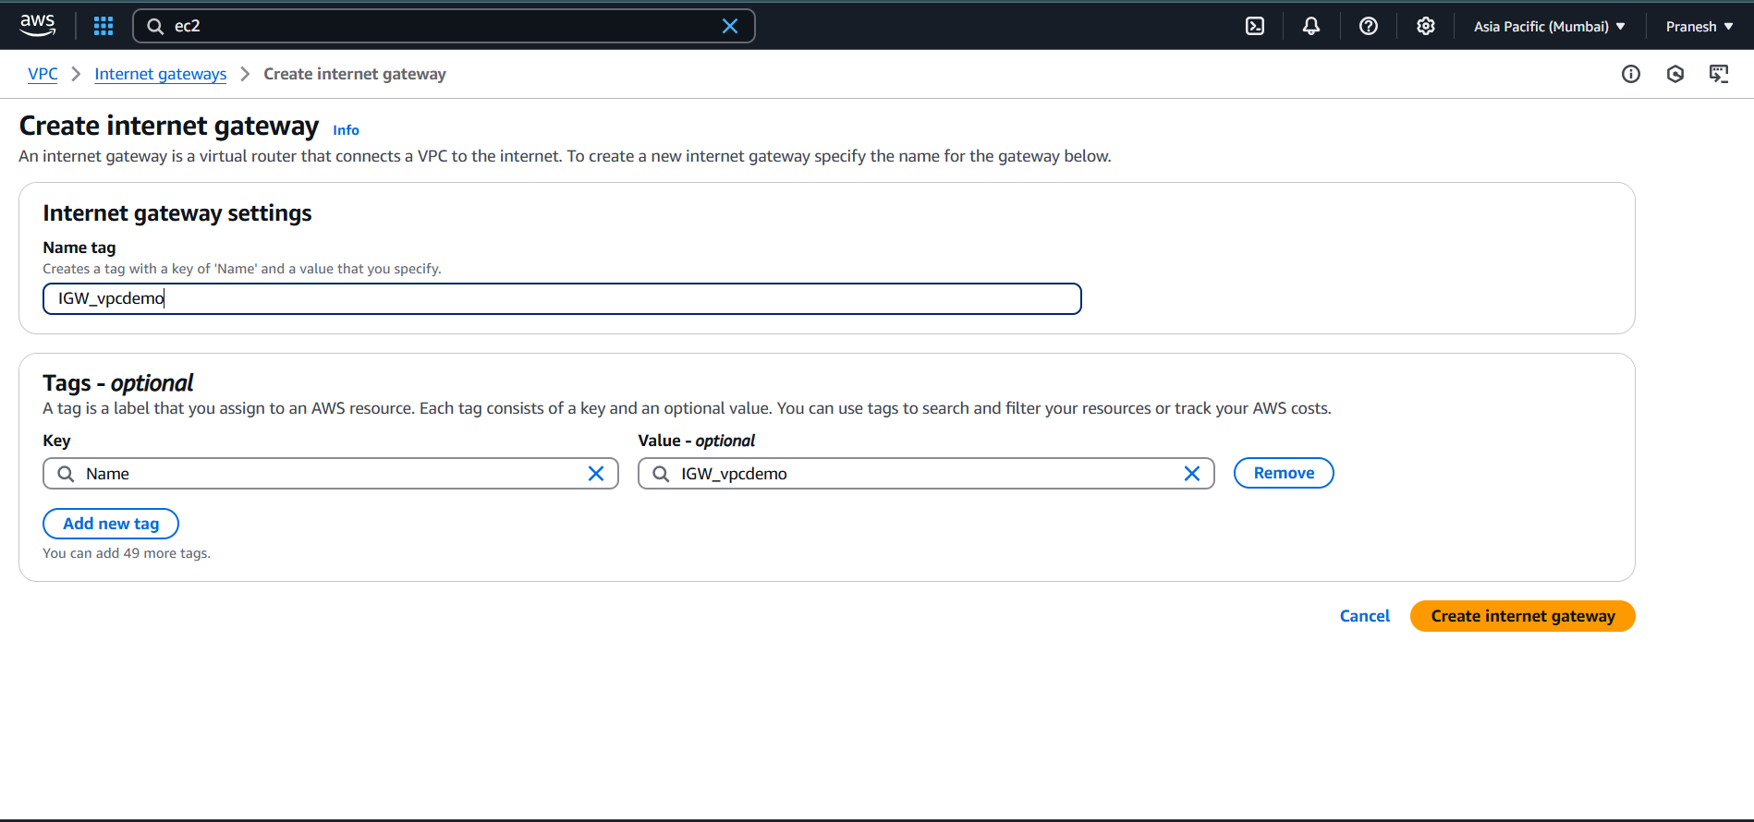

Step 5:

Associate the Subnet and IGW to the route tables.

IGW:

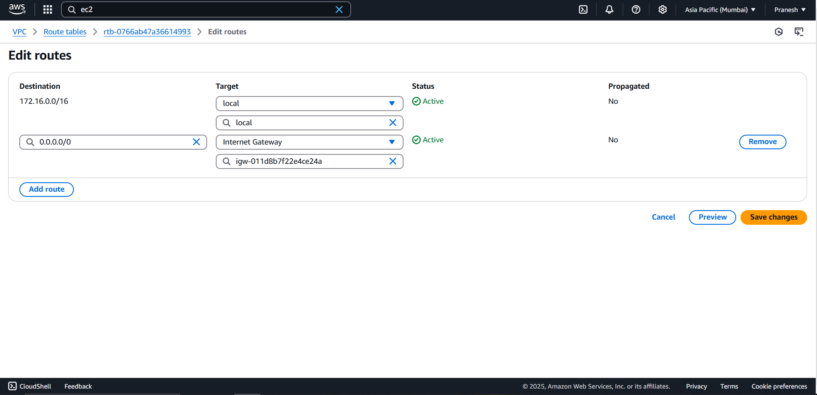

Public subnet association nd private subnet association:

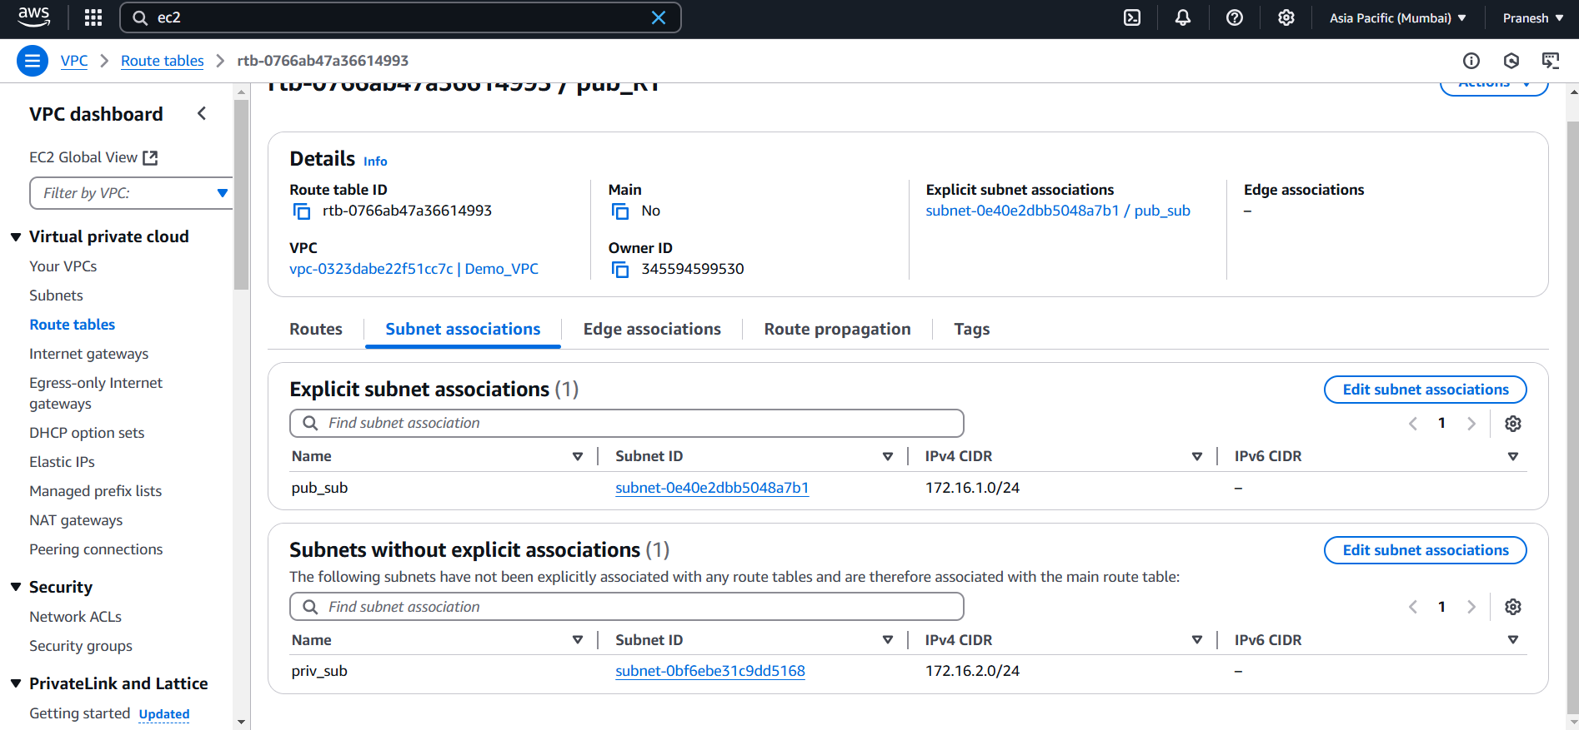

Step 6:

Create Security groups for both Public and private

Enable Port RDP(3389) and HTTP (80)

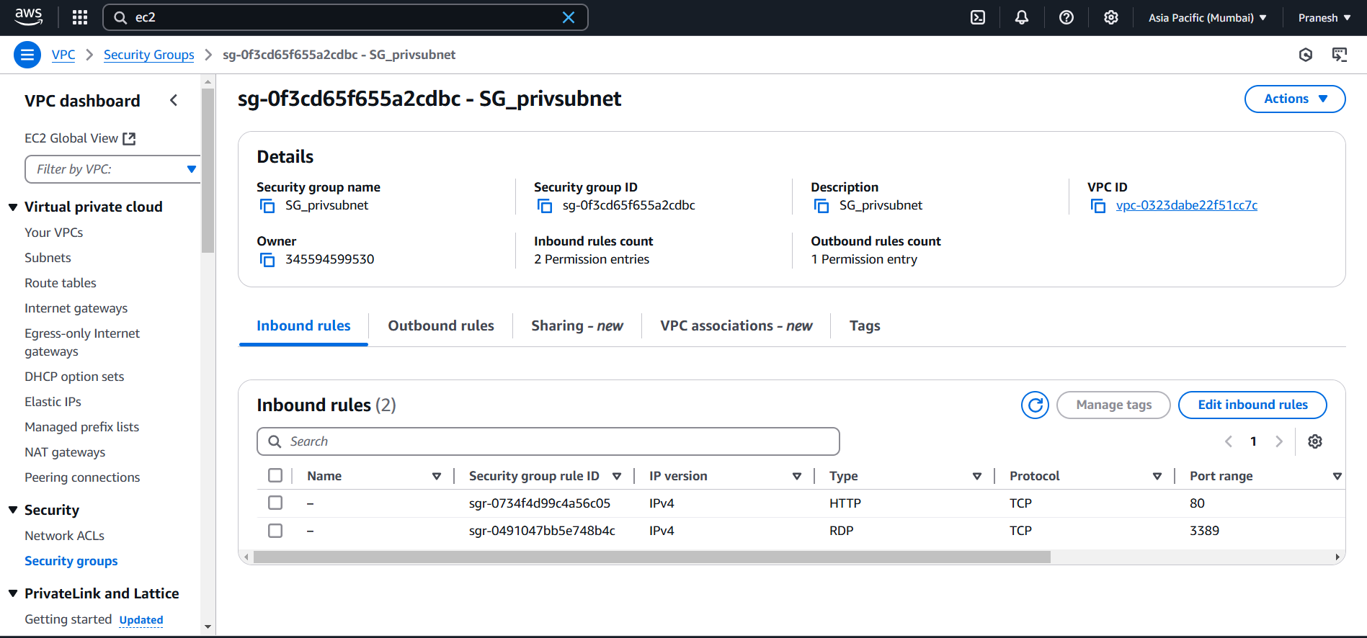

Step 7:

Create an instance For public (APP server):

1. Create with Windows Server
2. Add with VPC
3. Add Public subnet
4. Add existing SG (public SG)
5. Launch the instance.

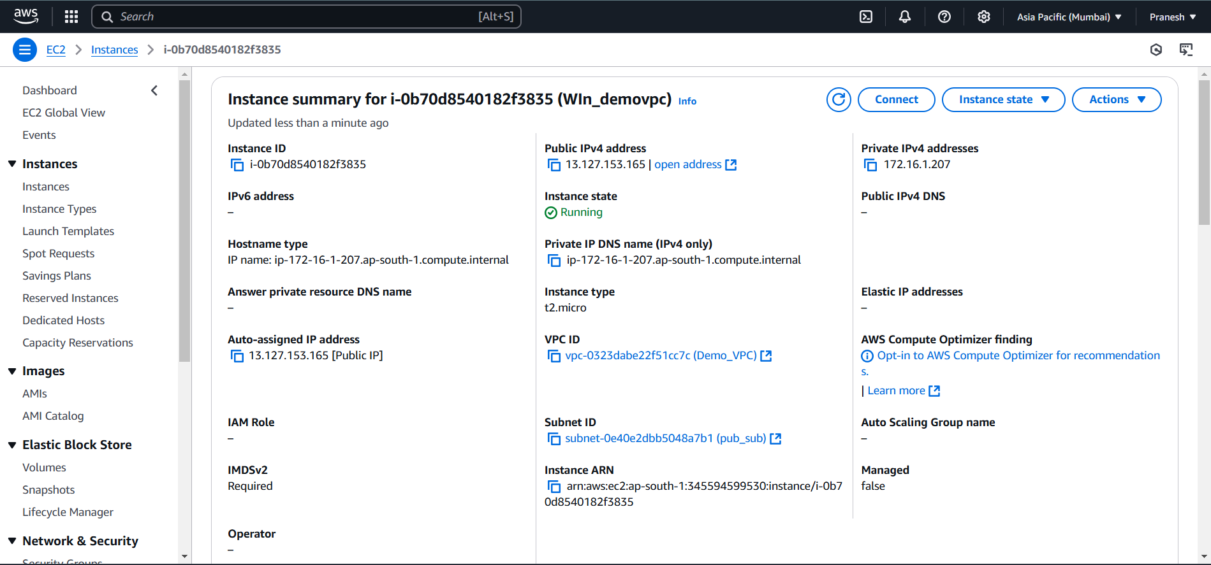

We have created an Instance under one VPC, Now deploy one App into the instance and check the application can access by outside Users via INTERNET.

To deploy app in Windows Instance:

1. Connect to the Server with RDP

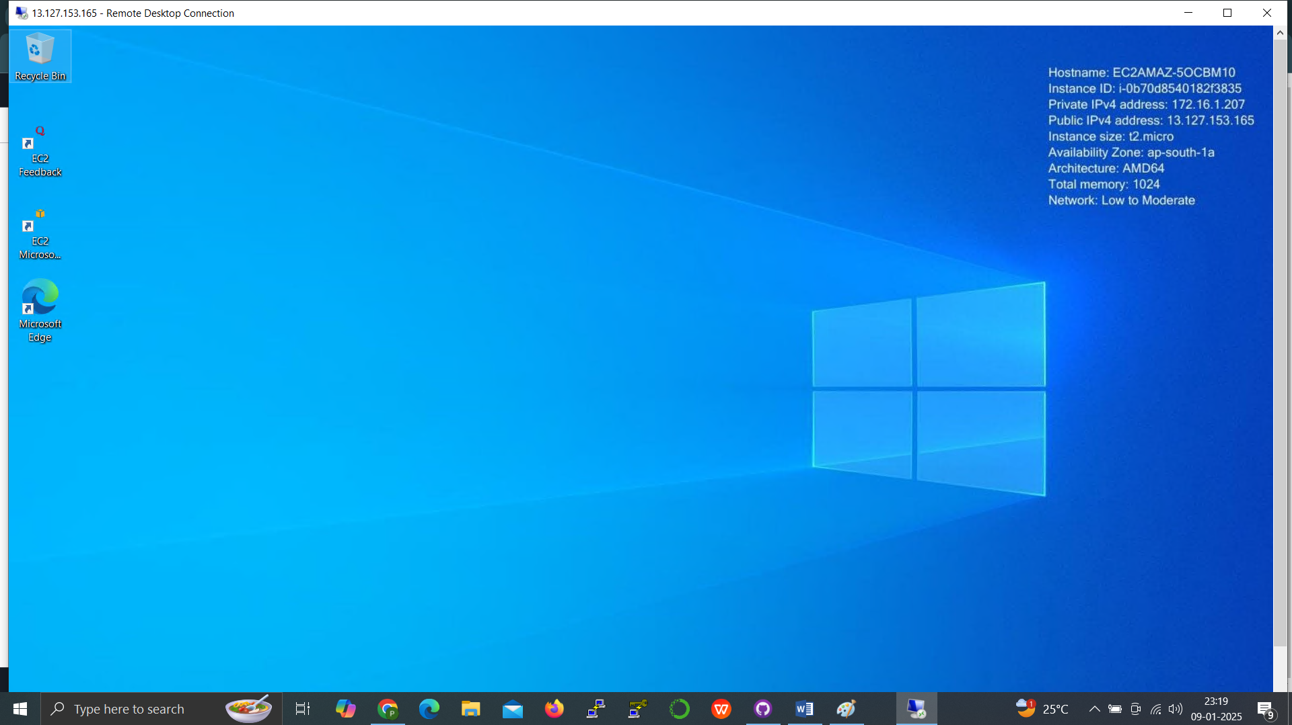

1. Set up a IIS( Windows web Server) in Server Manager.

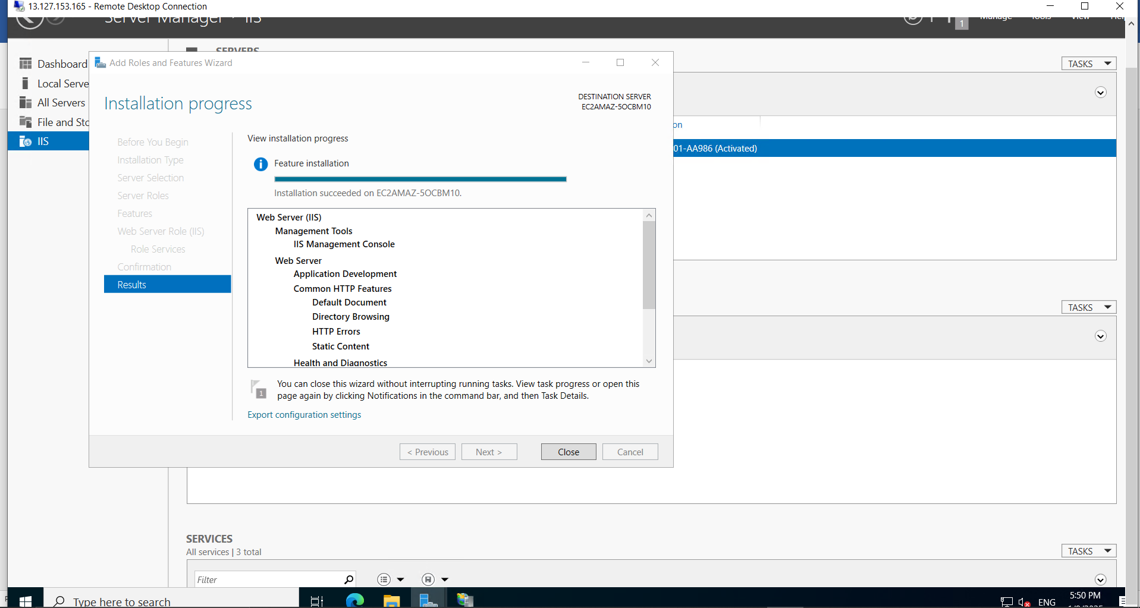

1. Copy the APP Code (HTML,CSS) to one path

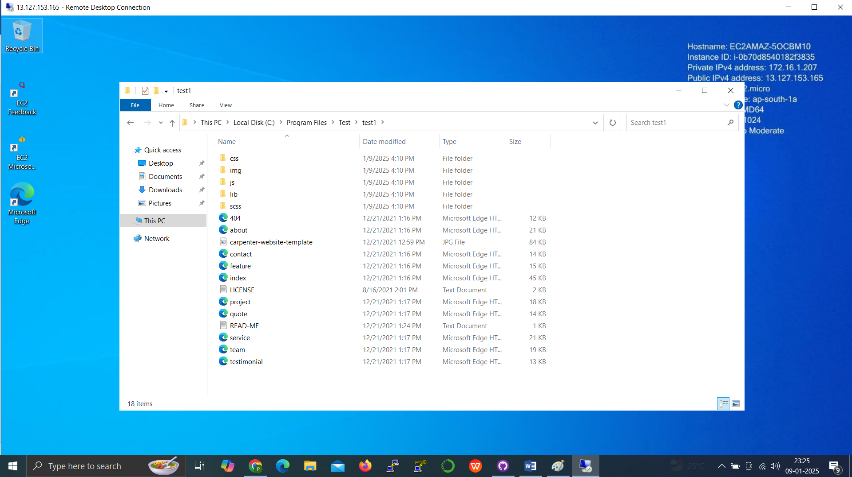

4.Add new site and give name,(app)path to the new site in IIS Manager

Assign port number 80 http

Restart the service

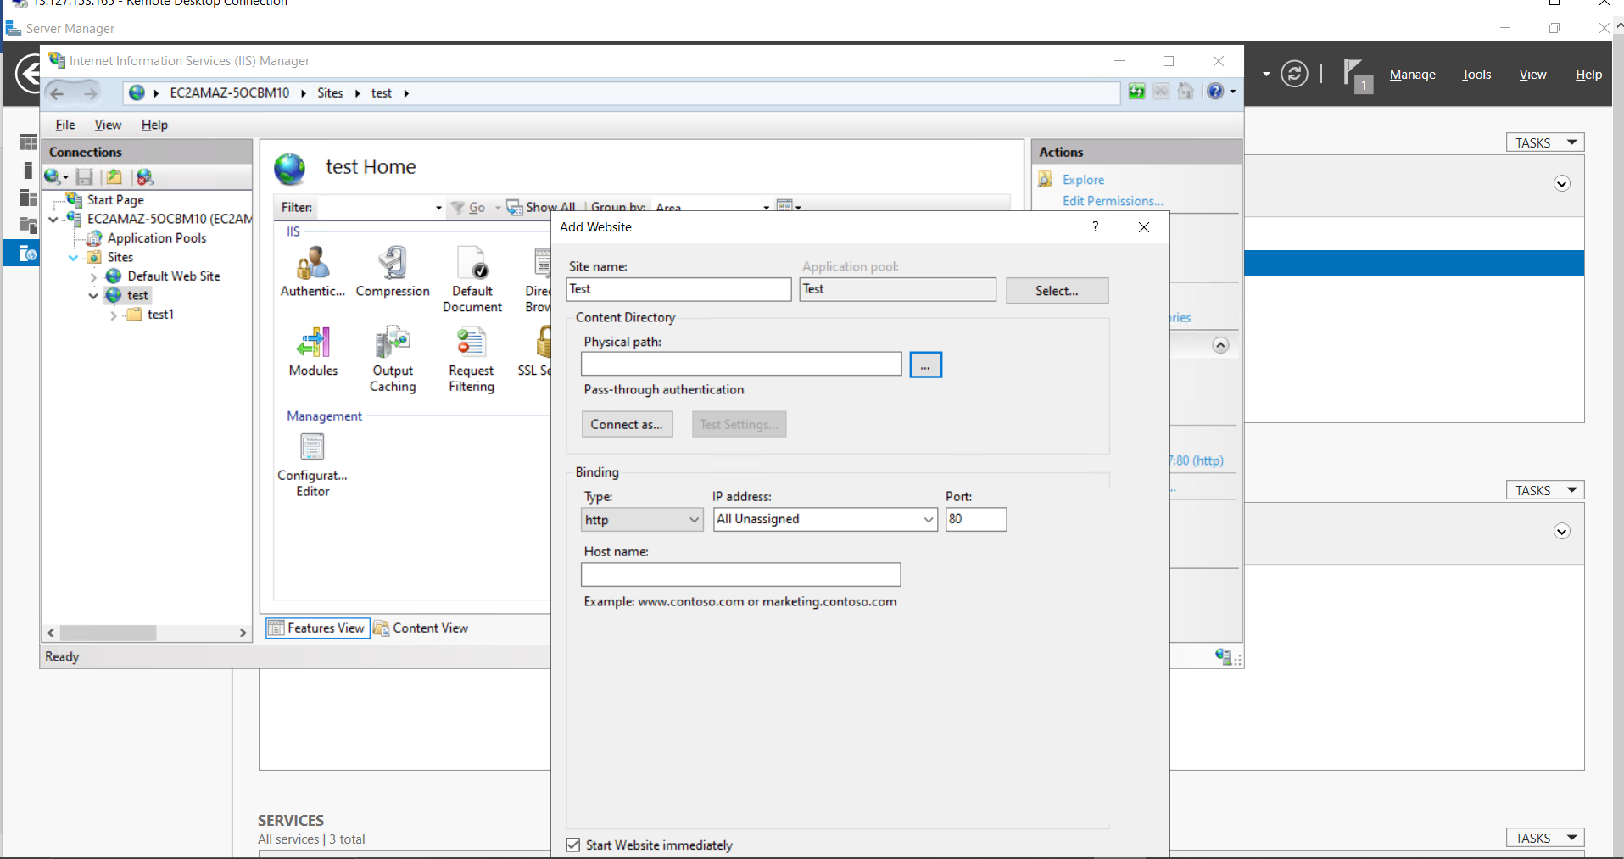

Now App was deployed on the Server to check give public ip of the instance with path in local machine



Now the users outside the network can access the application!!